ID Document Model Schema

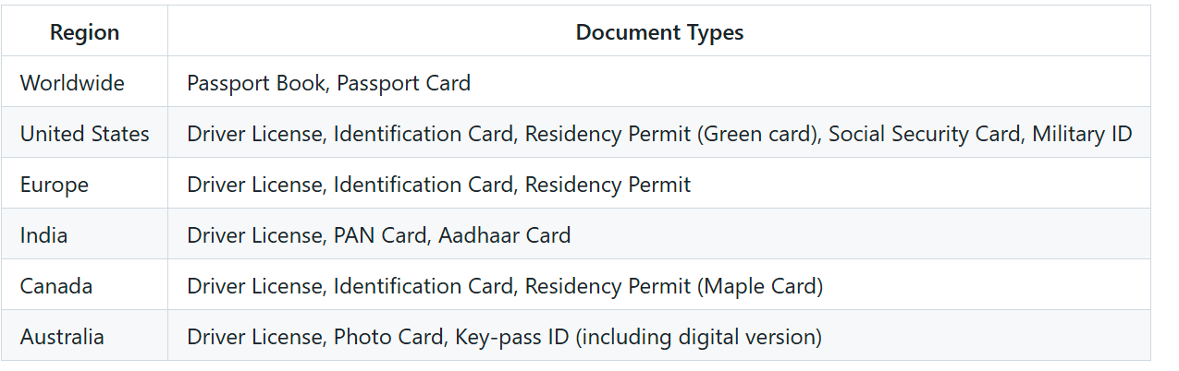

**Supported document fields**

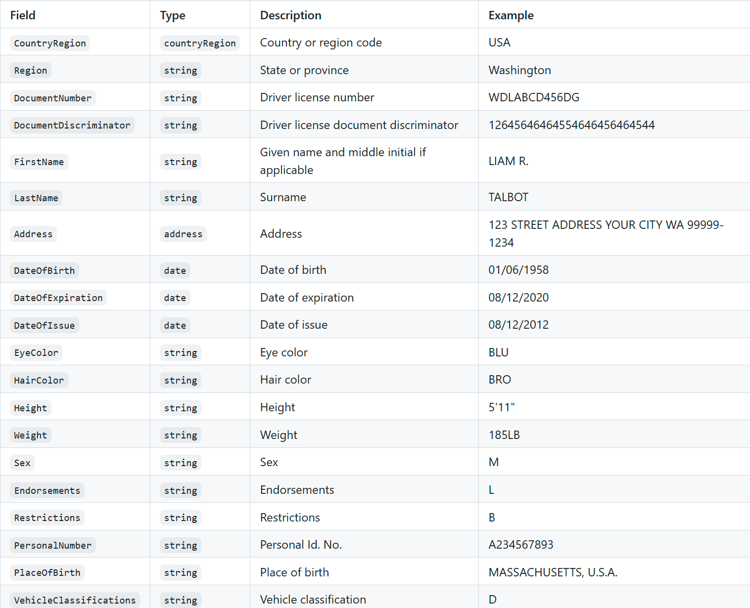

Pass-Port

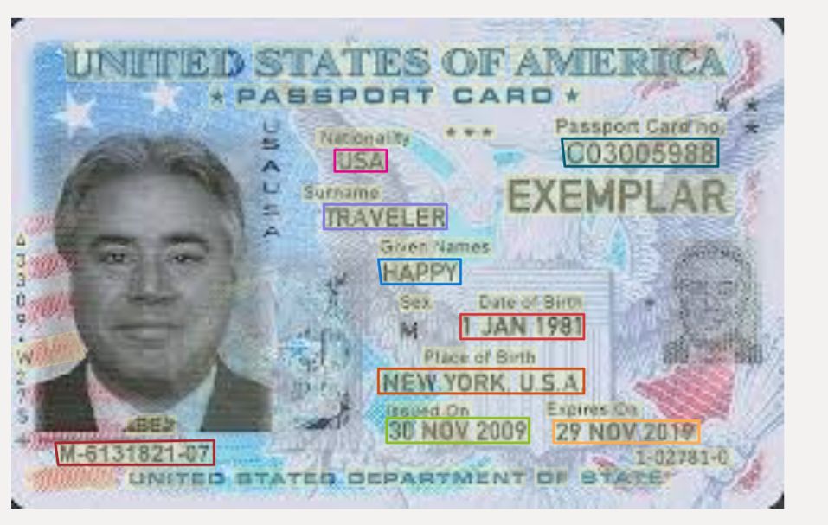

Fields Picked

Nationality

Passport number

Date of Issue

Date of Expiration

First Name

Last Name

Place of Birth

Personal Number



SSN

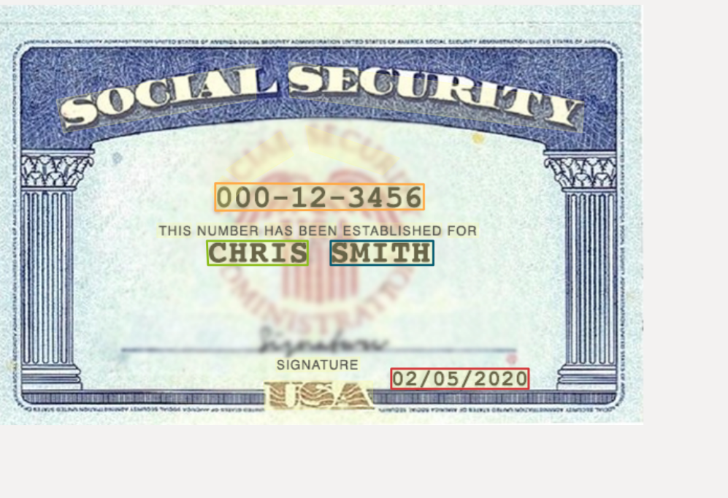

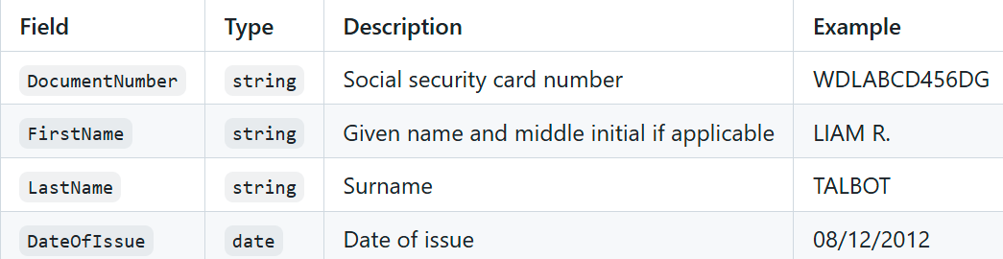

Driving License

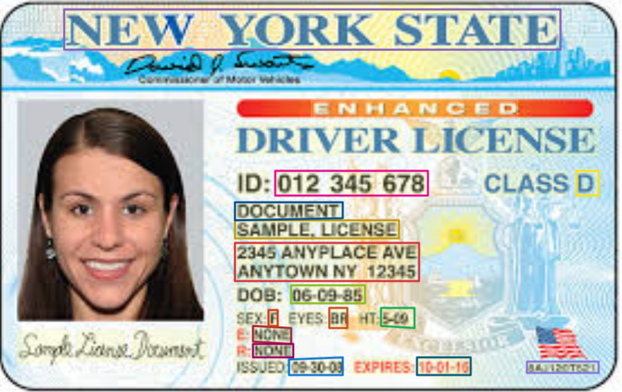

Fields Picked

(State or region where ID is Issued

ID number

First Name

Last Name

Address

DOB

Gender

Eye Color

Height

Data of Issue

Date of Expiry)

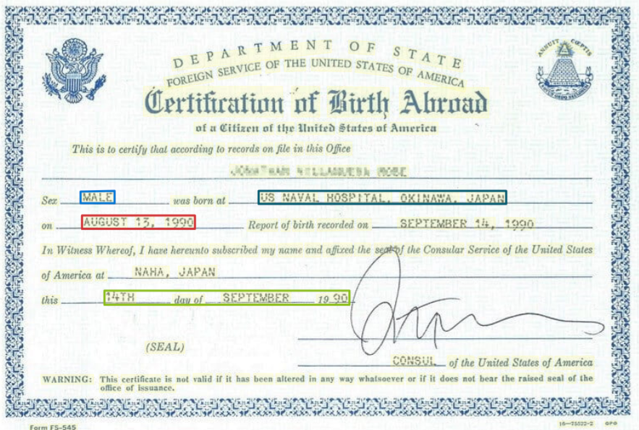

**Fields Picked**

Gender

Birth Location

Name

DOB

Date of Issue

Marriage Certificate

